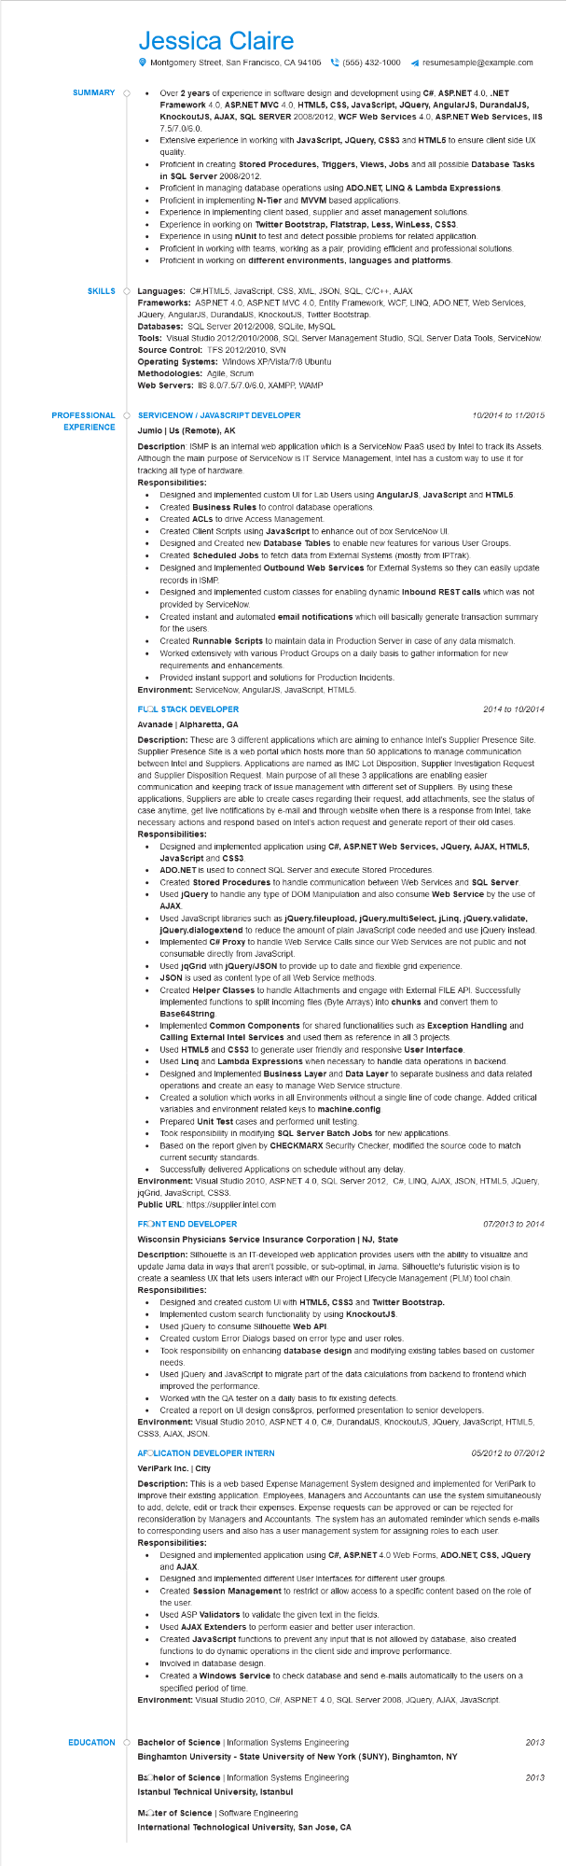
SUMMARY
SKILLS
Jessica Claire
•
•
•
Montgomery Street, San Francisco, CA 94105(555) 432-1000 ◄ resumesample@example.com
Over 2 years of experience in software design and development using C#, ASP.NET 4.0, .NET Framework 4.0, ASP.NET MVC 4.0, HTML5, CSS, JavaScript, JQuery, AngularJS, DurandalJS, KnockoutJS, AJAX, SQL SERVER 2008/2012, WCF Web Services 4.0, ASP.NET Web Services, IIS 7.5/7.0/6.0
Extensive experience in working with JavaScript, JQuery, CSS3 and HTML5 to ensure client side UX quality.
Proficient in creating Stored Procedures, Triggers, Views, Jobs and all possible Database Tasks in SQL Server 2008/2012.
Proficient in managing database operations using ADO.NET, LINQ & Lambda Expressions. Proficient in implementing N-Tier and MVVM based applications.
Experience in implementing client based, supplier and asset management solutions.
Experience in working on Twitter Bootstrap, Flatstrap, Less, WinLess, CSS3.
Experience in using nUnit to test and detect possible problems for related application.
Proficient in working with teams, working as a pair, providing efficient and professional solutions. Proficient in working on different environments, languages and platforms.
Languages: C#,HTML5, JavaScript, CSS, XML, JSON, SQL, C/C++, AJAX
Frameworks: ASP.NET 4.0, ASP.NET MVC 4.0, Entity Framework, WCF, LINQ, ADO.NET, Web Services, JQuery, AngularJS, DurandalJS, KnockoutJS, Twitter Bootstrap.
Databases: SQL Server 2012/2008, SQLite, MySQL
Tools: Visual Studio 2012/2010/2008, SQL Server Management Studio, SQL Server Data Tools, ServiceNow. Source Control: TFS 2012/2010, SVN
Operating Systems: Windows XP/Vista/7/8 Ubuntu
Methodologies: Agile, Scrum
Web Servers: IIS 8.0/7.5/7.0/6.0, XAMPP, WAMP
PROFESSIONAL
SERVICENOW/JAVASCRIPT DEVELOPER
EXPERIENCE
Jumio | Us (Remote), AK
10/2014 to 11/2015
Description: ISMP is an internal web application which is a ServiceNow PaaS used by Intel to track its Assets. Although the main purpose of ServiceNow is IT Service Management, Intel has a custom way to use it for tracking all type of hardware.
Responsibilities:
•
Designed and implemented custom UI for Lab Users using AngularJS, JavaScript and HTML5. Created Business Rules to control database operations.
Created ACLs to drive Access Management.
Created Client Scripts using JavaScript to enhance out of box ServiceNow UI.
Designed and Created new Database Tables to enable new features for various User Groups.
Created Scheduled Jobs to fetch data from External Systems (mostly from IPTrak).
•
Designed and Implemented Outbound Web Services for External Systems so they can easily update records in ISMP.
Designed and implemented custom classes for enabling dynamic Inbound REST calls which was not provided by ServiceNow.
Created instant and automated email notifications which will basically generate transaction summary for the users.
Created Runnable Scripts to maintain data in Production Server in case of any data mismatch. • Worked extensively with various Product Groups on a daily basis to gather information for new requirements and enhancements.
•
Provided instant support and solutions for Production Incidents. Environment: ServiceNow, AngularJS, JavaScript, HTML5.
FLOL STACK DEVELOPER
Avanade | Alpharetta, GA
2014 to 10/2014
Description: These are 3 different applications which are aiming to enhance Intel's Supplier Presence Site. Supplier Presence Site is a web portal which hosts more than 50 applications to manage communication between Intel and Suppliers. Applications are named as IMC Lot Disposition, Supplier Investigation Request and Supplier Disposition Request. Main purpose of all these 3 applications are enabling easier communication and keeping track of issue management with different set of Suppliers. By using these applications, Suppliers are able to create cases regarding their request, add attachments, see the status of case anytime, get live notifications by e-mail and through website when there is a response from Intel, take necessary actions and respond based on Intel's action request and generate report of their old cases. Responsibilities:
•
Designed and implemented application using C#, ASP.NET Web Services, JQuery, AJAX, HTML5, JavaScript and CSS3.
• ADO.NET is used to connect SQL Server and execute Stored Procedures.
• Created Stored Procedures to handle communication between Web Services and SQL Server.
•
•
Used jQuery to handle any type of DOM Manipulation and also consume Web Service by the use of AJAX.
Used JavaScript libraries such as jQuery.fileupload, jQuery.multiSelect, jLinq, jQuery.validate, jQuery.dialogextend to reduce the amount of plain JavaScript code needed and use jQuery instead. Implemented C# Proxy to handle Web Service Calls since our Web Services are not public and not consumable directly from JavaScript.
Used jqGrid with jQuery/JSON to provide up to date and flexible grid experience. JSON is used as content type of all Web Service methods.
Created Helper Classes to handle Attachments and engage with External FILE API. Successfully implemented functions to split incoming files (Byte Arrays) into chunks and convert them to Base64String.
Implemented Common Components for shared functionalities such as Exception Handling and Calling External Intel Services and used them as reference in all 3 projects.
Used HTML5 and CSS3 to generate user friendly and responsive User Interface.
Used Linq and Lambda Expressions when necessary to handle data operations in backend. Designed and Implemented Business Layer and Data Layer to separate business and data related operations and create an easy to manage Web Service structure.
Created a solution which works in all Environments without a single line of code change. Added critical variables and environment related keys to machine.config.
Prepared Unit Test cases and performed unit testing.
Took responsibility in modifying SQL Server Batch Jobs for new applications.
Based on the report given by CHECKMARX Security Checker, modified the source code to match current security standards.
Successfully delivered Applications on schedule without any delay.
Environment: Visual Studio 2010, ASP.NET 4.0, SQL Server 2012, C#, LINQ, AJAX, JSON, HTML5, JQuery, jqGrid, JavaScript, CSS3.
Public URL: https://supplier.intel.com
FRONT END DEVELOPER
Wisconsin Physicians Service Insurance Corporation | NJ, State
07/2013 to 2014
Description: Silhouette is an IT-developed web application provides users with the ability to visualize and update Jama data in ways that aren't possible, or sub-optimal, in Jama. Silhouette's futuristic vision is to create a seamless UX that lets users interact with our Project Lifecycle Management (PLM) tool chain. Responsibilities:
• Designed and created custom UI with HTML5, CSS3 and Twitter Bootstrap.
Implemented custom search functionality by using KnockoutJS.
.
Used jQuery to consume Silhouette Web API.
Created custom Error Dialogs based on error type and user roles.
•
Took responsibility on enhancing database design and modifying existing tables based on customer needs.
Used jQuery and JavaScript to migrate part of the data calculations from backend to frontend which improved the performance.
Worked with the QA tester on a daily basis to fix existing defects.
Created a report on UI design cons&pros, performed presentation to senior developers.
Environment: Visual Studio 2010, ASP.NET 4.0, C#, DurandalJS, KnockoutJS, JQuery, JavaScript, HTML5, CSS3, AJAX, JSON.
AFOLICATION DEVELOPER INTERN
VeriPark Inc. | City
05/2012 to 07/2012
Description: This is a web based Expense Management System designed and implemented for VeriPark to improve their existing application. Employees, Managers and Accountants can use the system simultaneously to add, delete, edit or track their expenses. Expense requests can be approved or can be rejected for reconsideration by Managers and Accountants. The system has an automated reminder which sends e-mails to corresponding users and also has user management system for assigning roles to each user. Responsibilities:
Designed and implemented application using C#, ASP.NET 4.0 Web Forms, ADO.NET, CSS, JQuery and AJAX
Designed and implemented different User Interfaces for different user groups.
Created Session Management to restrict or allow access to a specific content based on the role of the user.
Used ASP Validators to validate the given text in the fields.
Used AJAX Extenders to perform easier and better user interaction.
Created JavaScript functions to prevent any input that is not allowed by database, also created functions to do dynamic operations in the client side and improve performance.
Involved in database design.
Created a Windows Service to check database and send e-mails automatically to the users on a specified period of time.
Environment: Visual Studio 2010, C#, ASP.NET 4.0, SQL Server 2008, JQuery, AJAX, JavaScript.
EDUCATION
Bachelor of Science | Information Systems Engineering
2013
Binghamton University - State University of New York (SUNY), Binghamton, NY
Bachelor of Science | Information Systems Engineering
2013
Istanbul Technical University, Istanbul
Moter of Science | Software Engineering
International Technological University, San Jose, CA

